1. **INTRODUCTION**
   1. Overview

Administrator should be able to create all base data including Semester, Candidate, Course and Lecturer, should have the ability to create Internal Results, Dean, who is one of the Lecturer, should be the only one with ability to update Internal Results, Re-evaluation can be initialized by Candidate for all Internal Results. Now only dean can update the marks after re-evaluation.

* 1. Purpose
* By this project we learned about creating apps in lightning app milestone-3.
* This project helps as to know about sales force which is a game-changing technology, with a host of productivity –boosting features.
* It helps as to create sales force object creation.
* Also we learned about Fields and Relationship of a custom objects
* We create user account smartly in sales force company as an employee
* It is very useful to our studies and career.
* We can also know about reports and dashboards form this project.
* By using this project we achieve knowledge and job.

1. **Problem Definition & Design Thinking**

2.1 Empathy Map

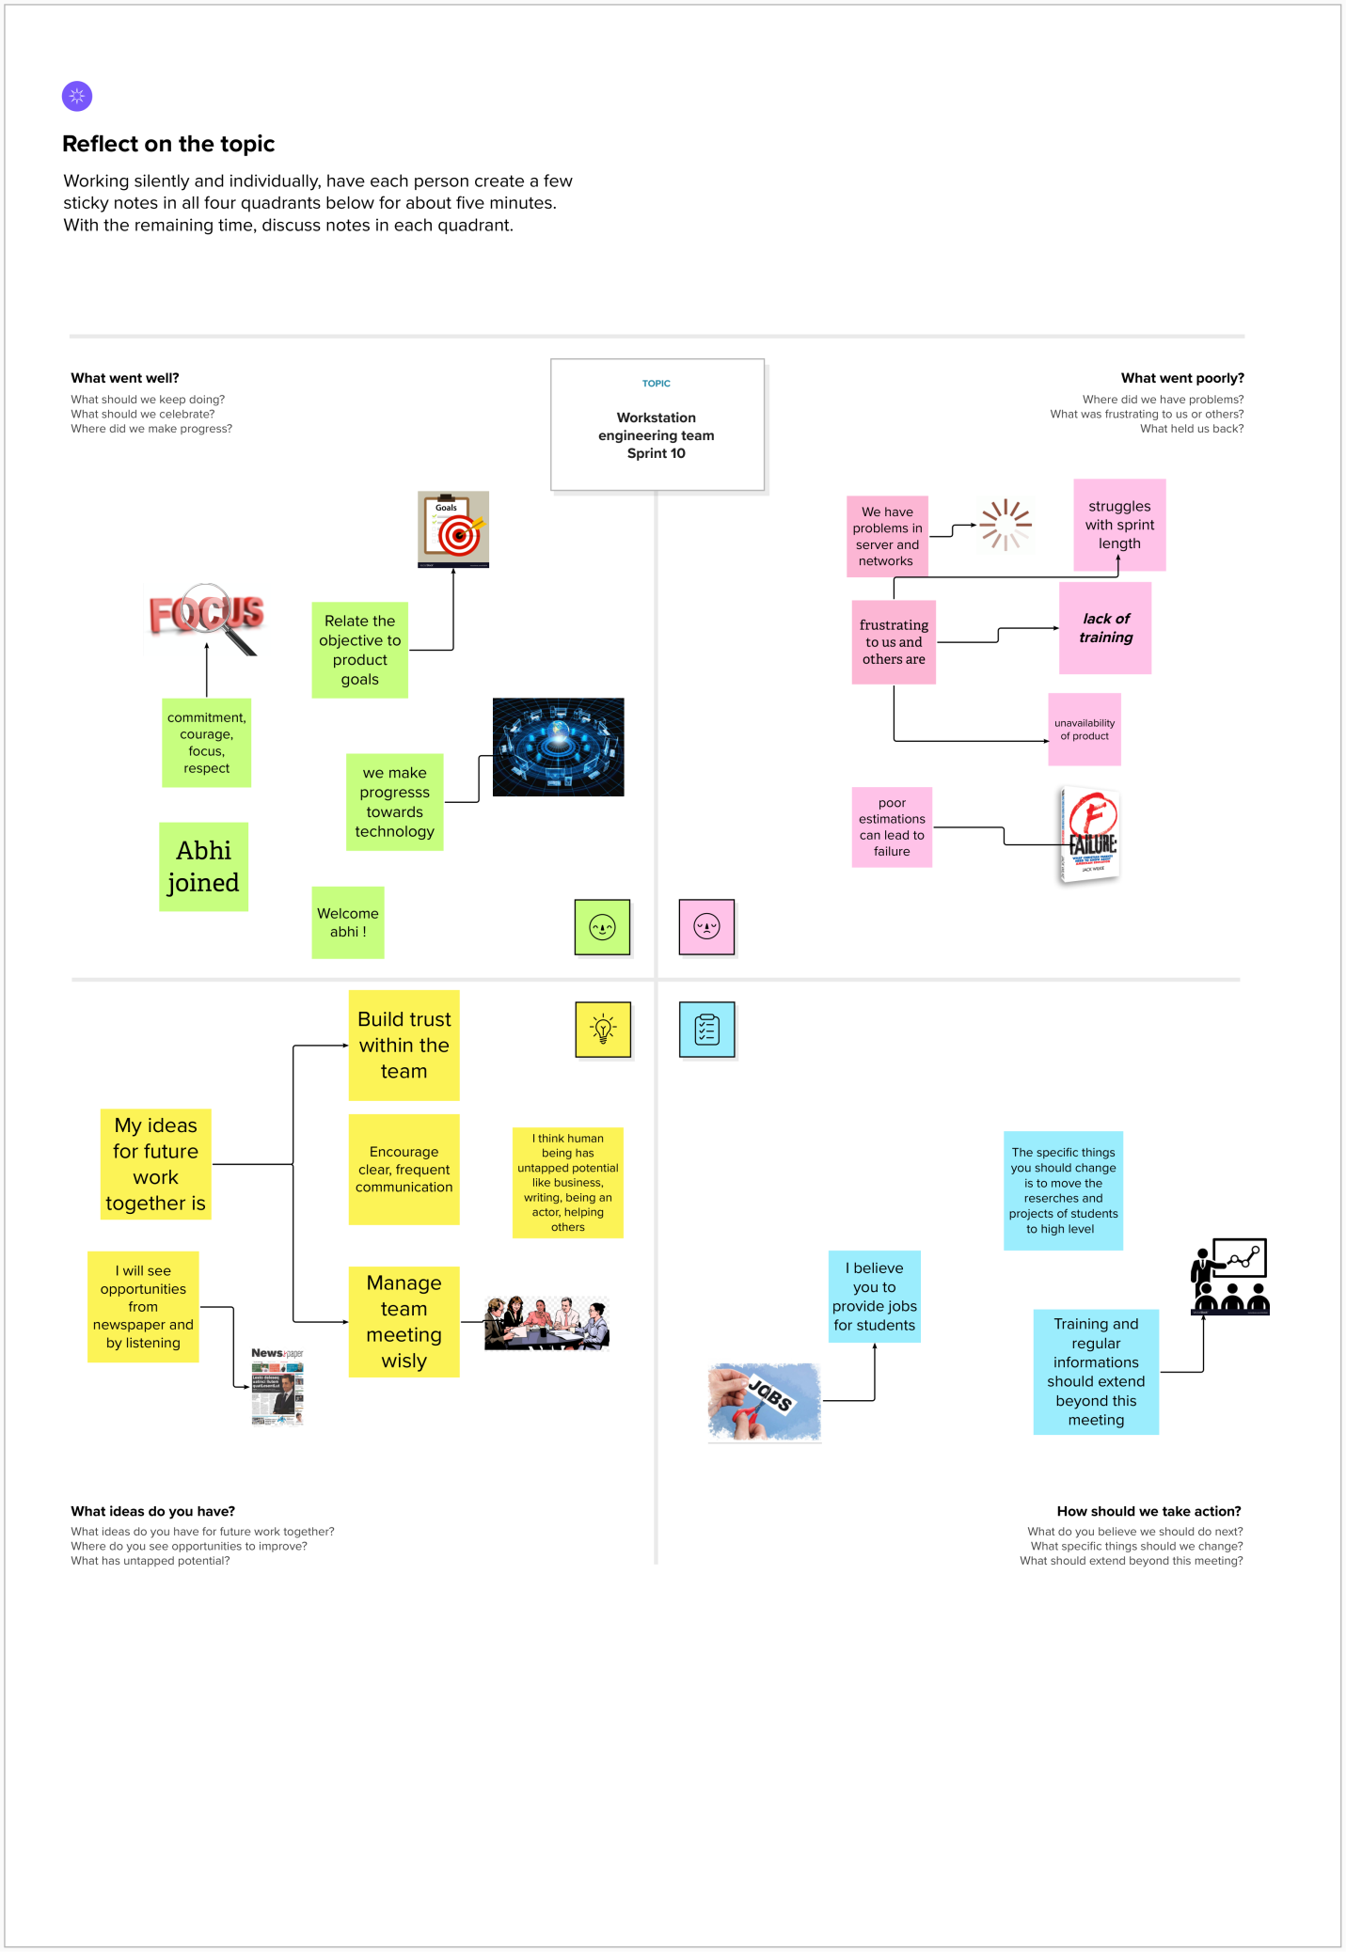

2.2 Ideation & Brainstroming

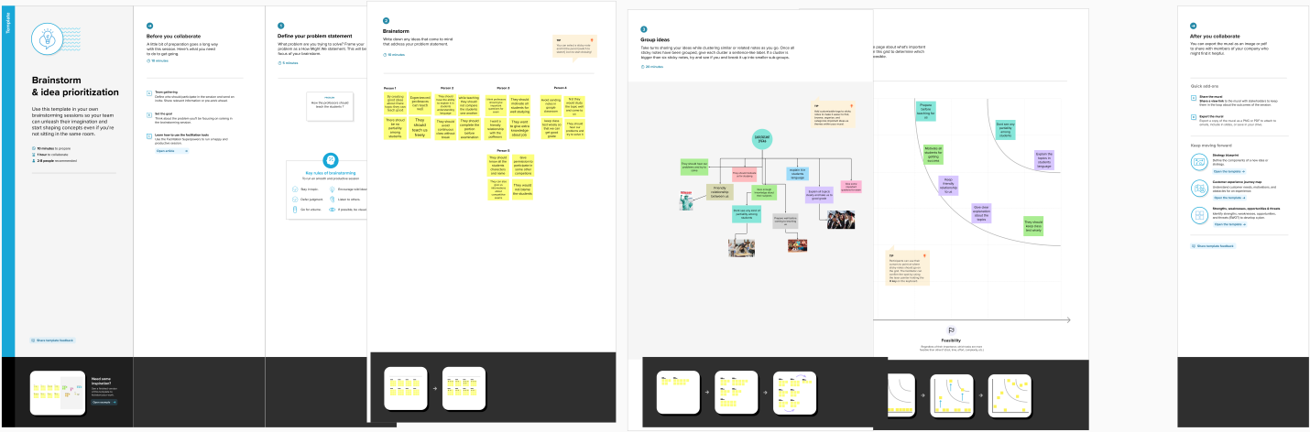

**RESULT**

**3.1** Data Model:

|  |  |
| --- | --- |
| Object Name | Fields in the object |
| Object 1 | |  |  | | --- | --- | | Field Label | Data type | | Semester Name | Text | |
| Object 2 | |  |  | | --- | --- | | Field Label | Data type | | Candidate Name | Text | |
| Object 3 | |  |  | | --- | --- | | Field Label | Data type | | Course details | Text | |
| Object 4 | |  |  | | --- | --- | | Field Label | Data type | | Lecturer Details | Text | |
| Object 5 | |  |  | | --- | --- | | Field Label | Data type | | Internal Results | Text | |

**3.2 Activity & Screenshot**

**Activity- 1 (object**)

**Custom objects**

1. Semester

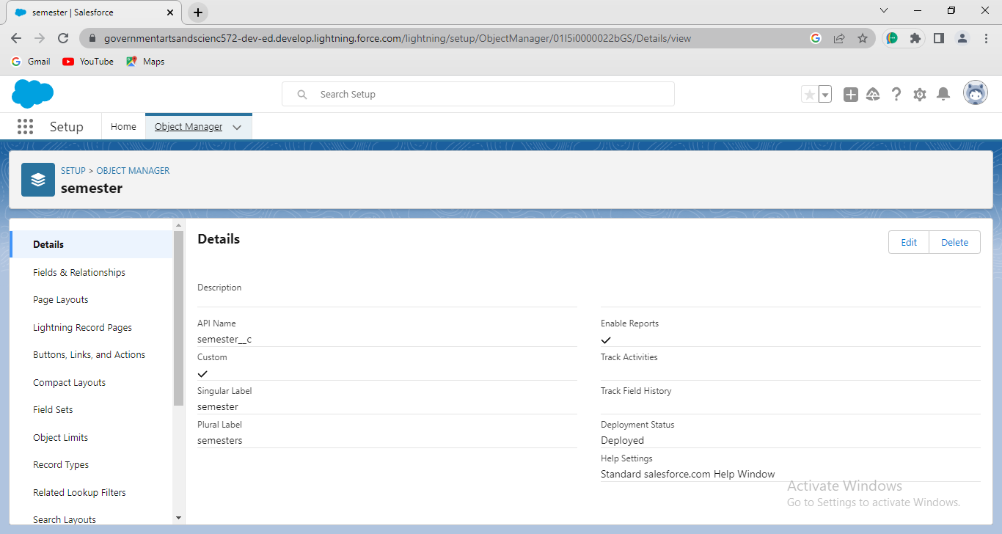

1. **Candidate**

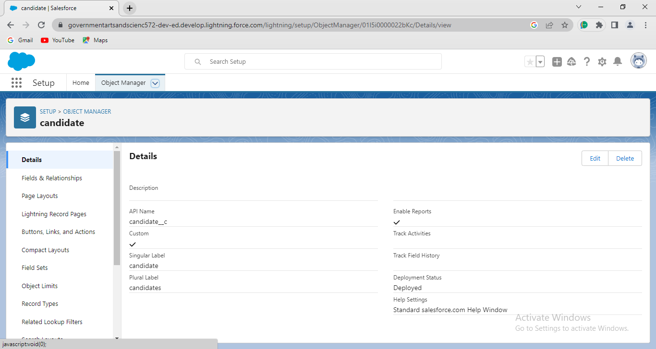

1. Course Details

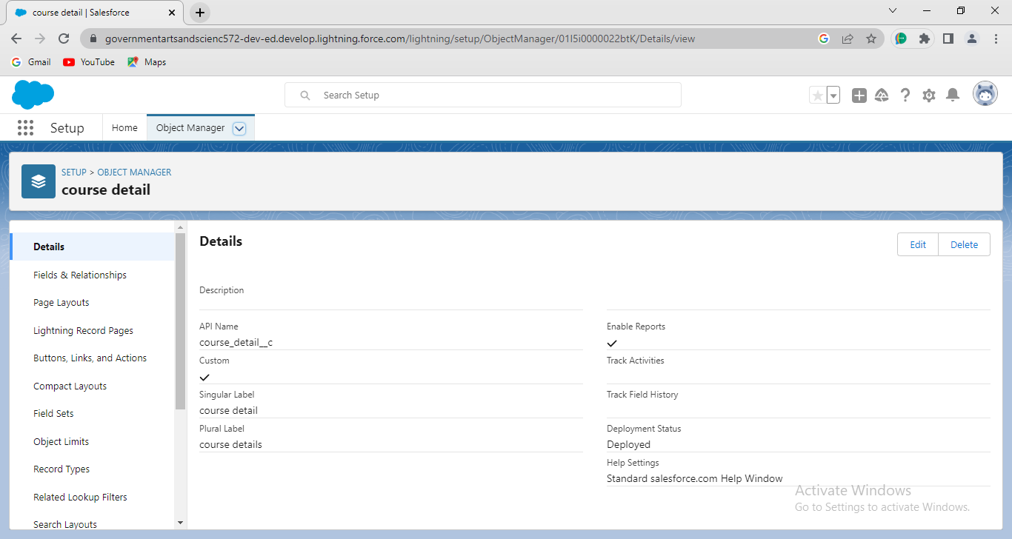

1. Lecturer Details

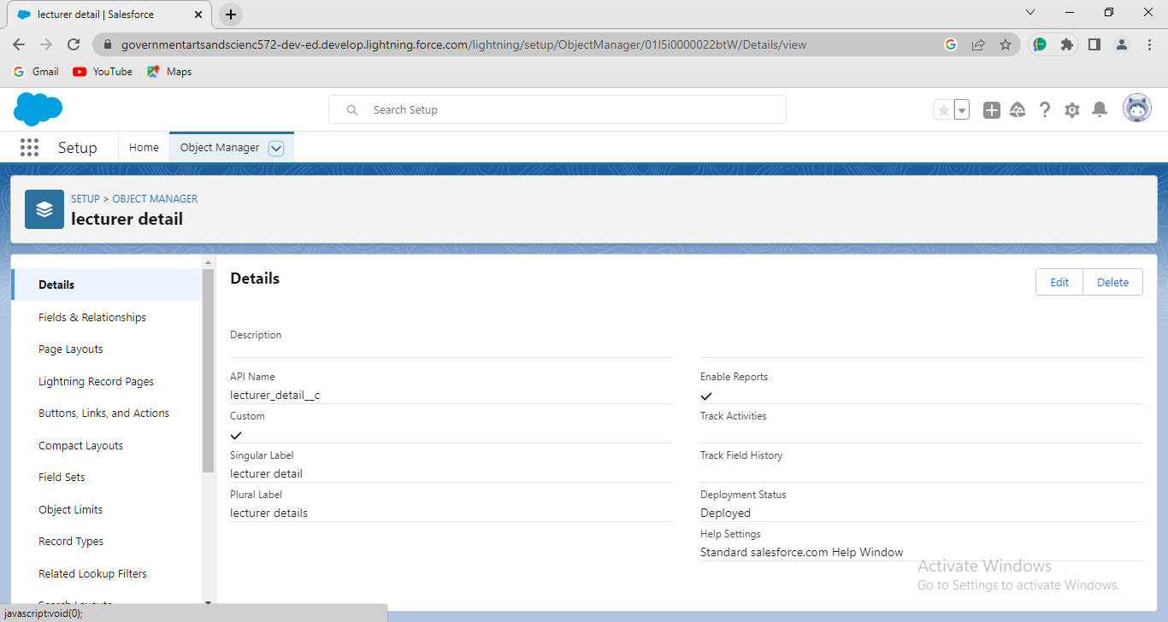

1. Internal Results

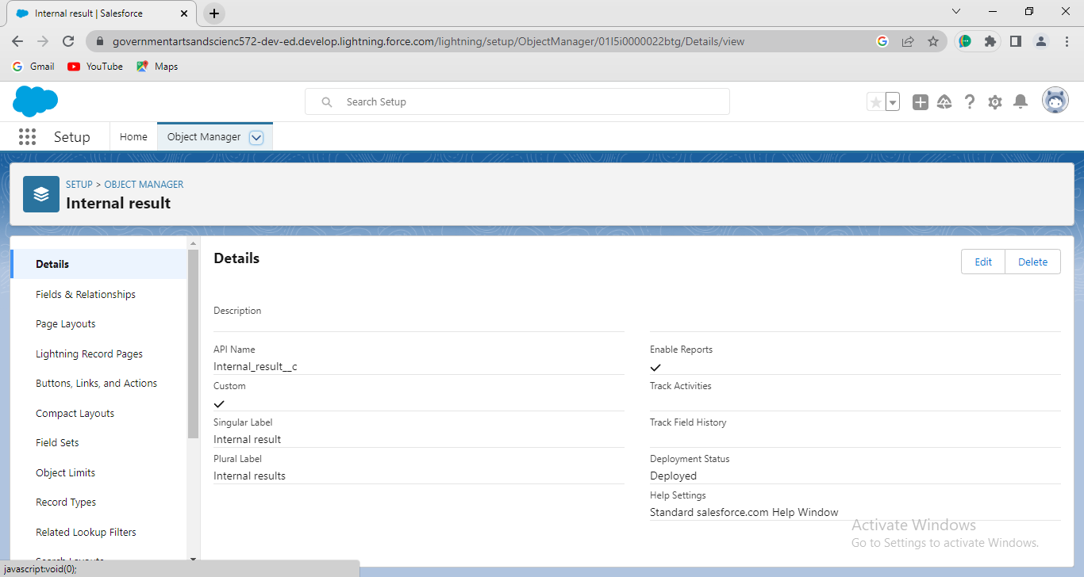

**Activity -2 (Fields and Relationship)**

1. **Semester**

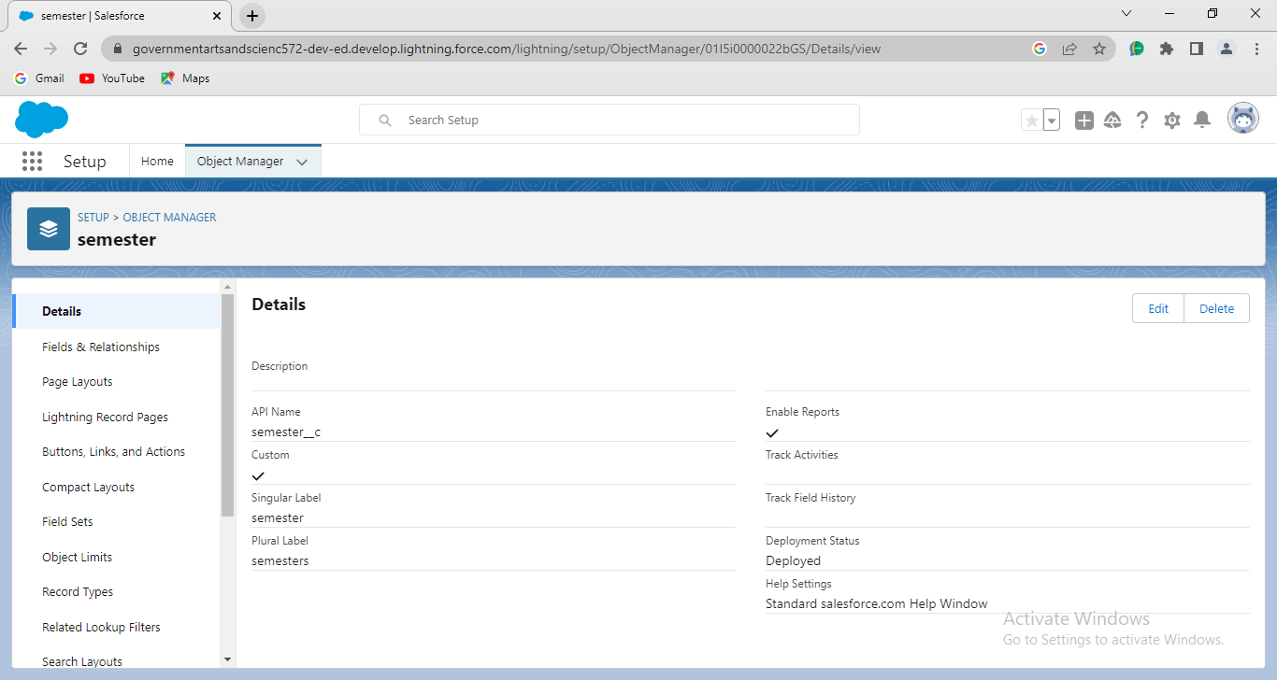

2.Candidate

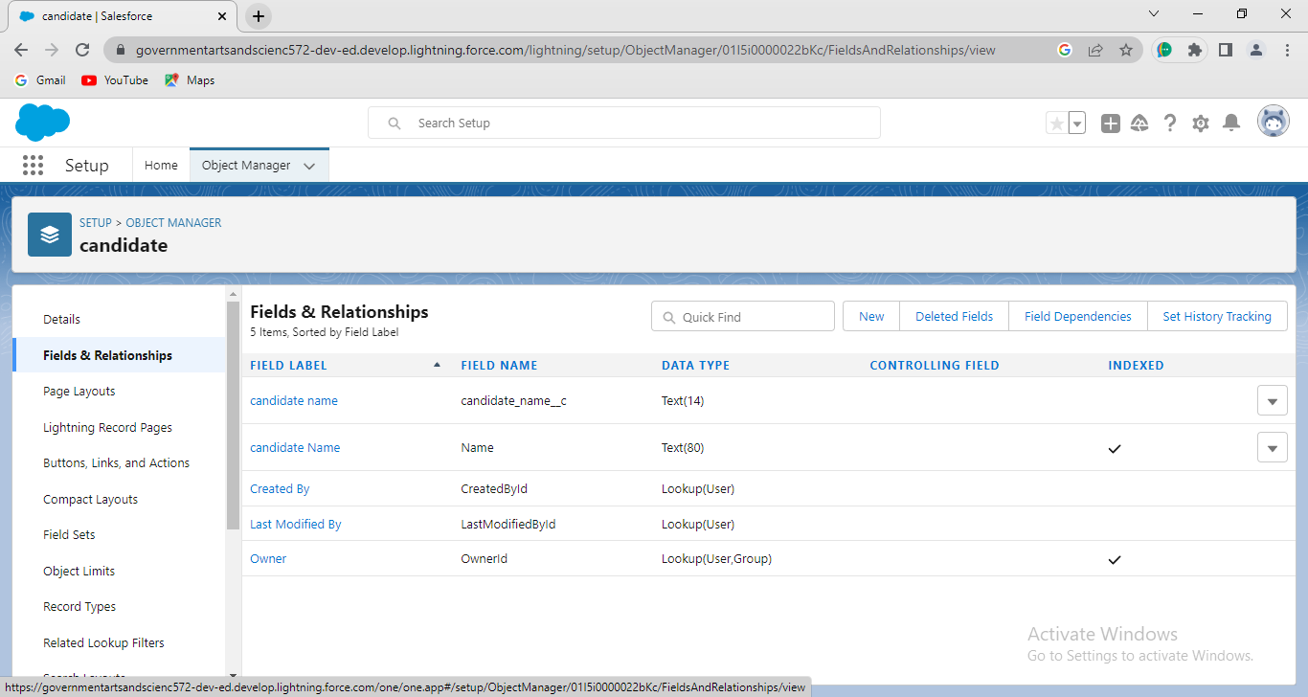

3.Course details

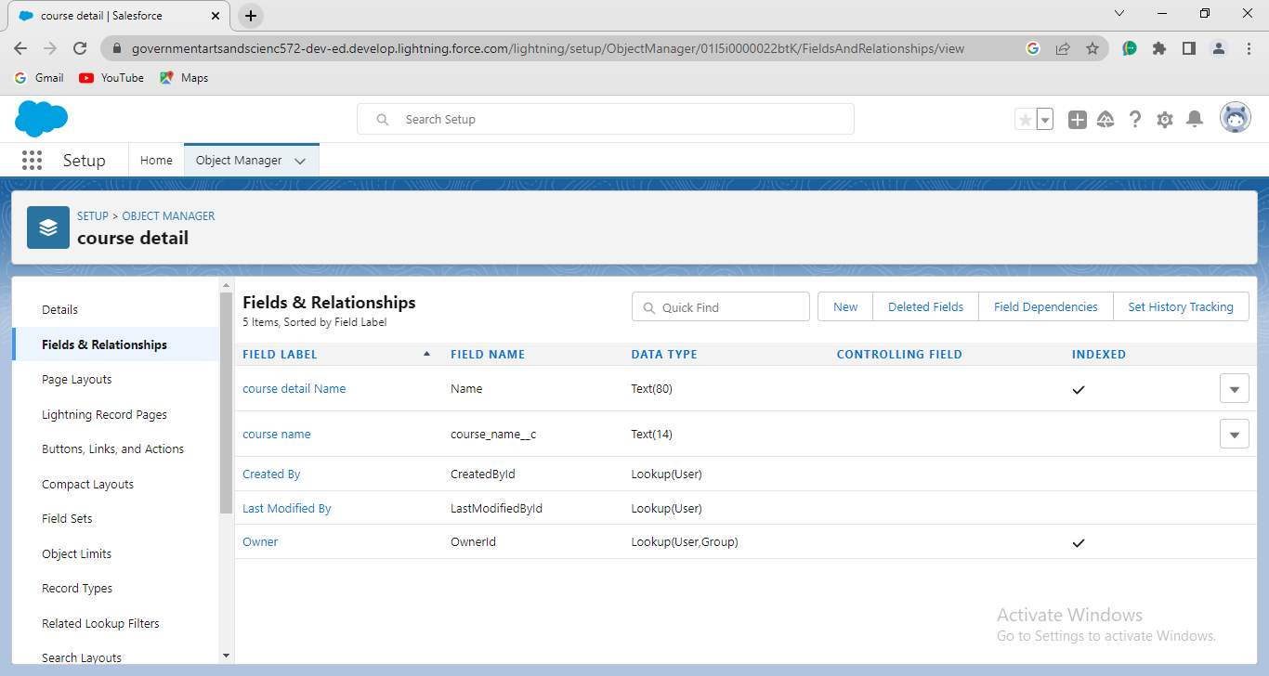

4.Lecturer Details

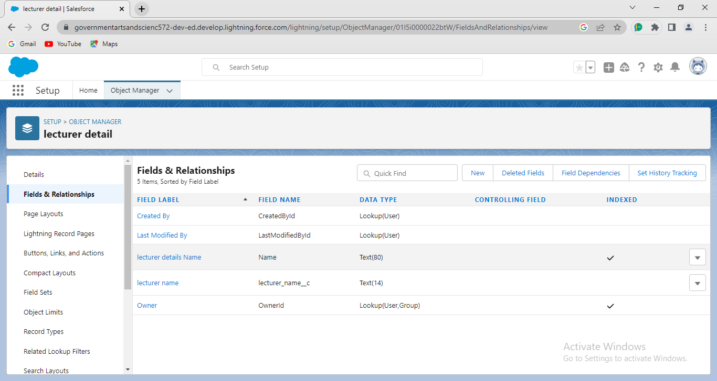

5.Internal results

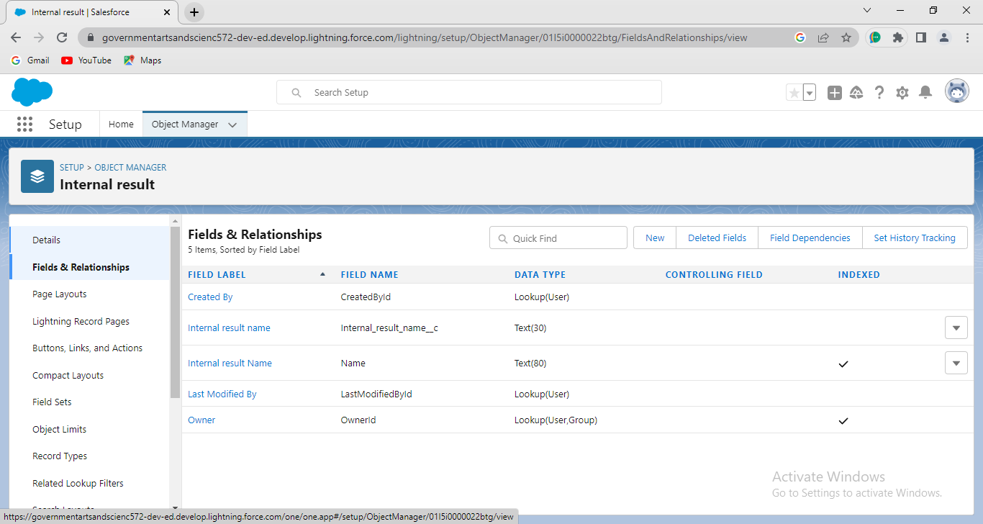

**Activity-3(Lightning App)**

**Creation of Candidate Internal Result Card app:**

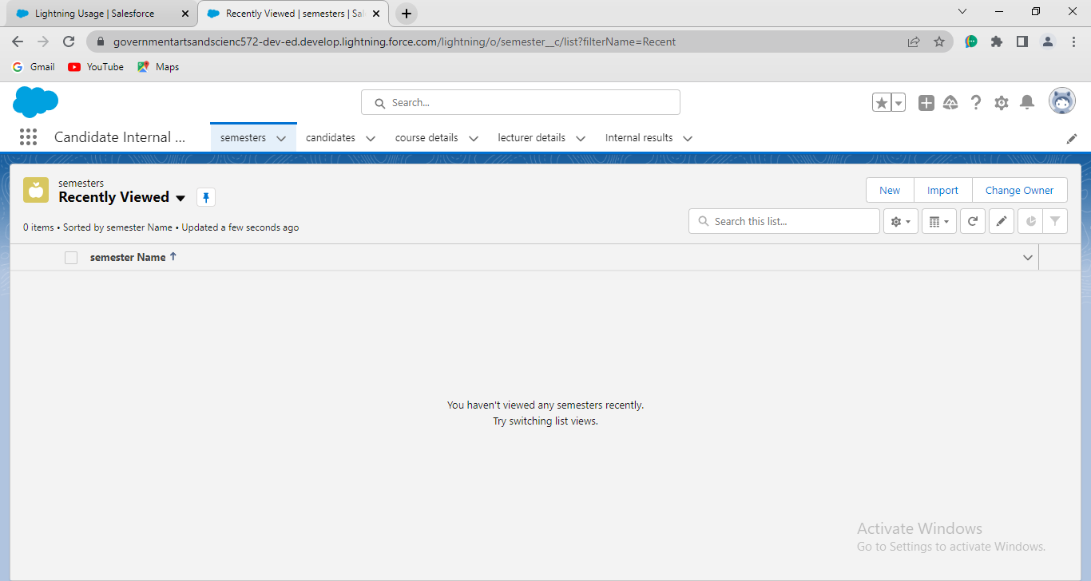

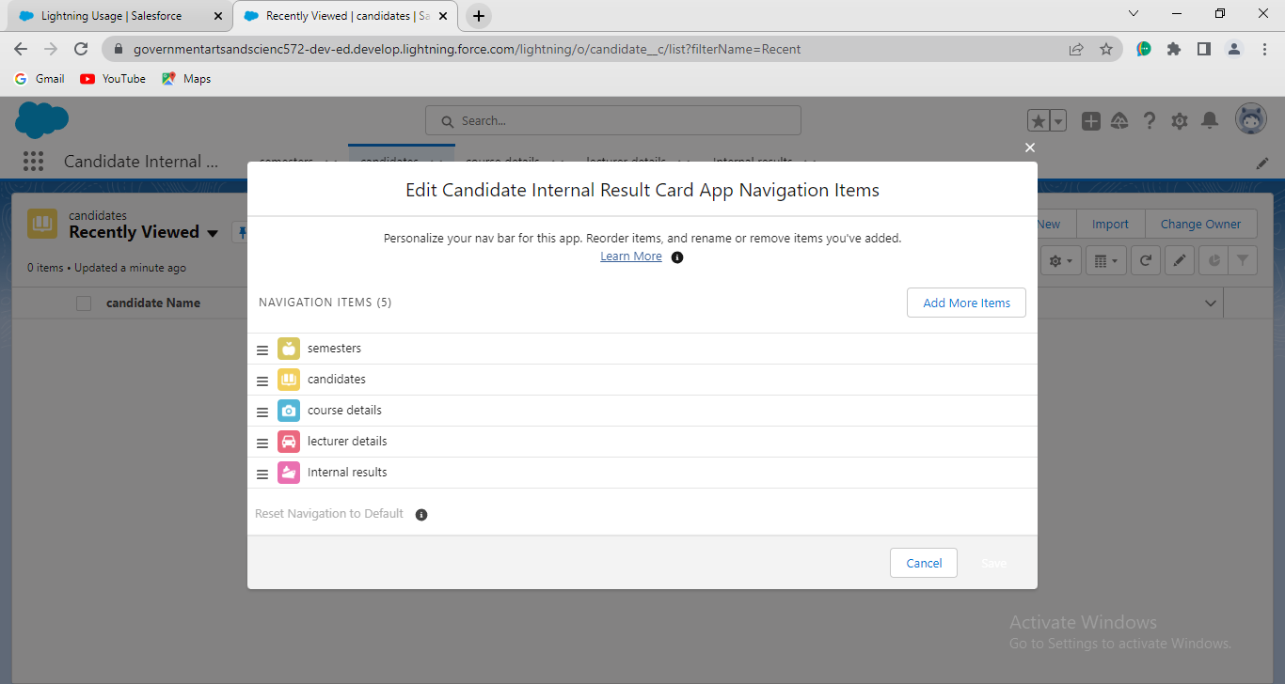

**Activity-4(Users)**

**Creation of Users:**

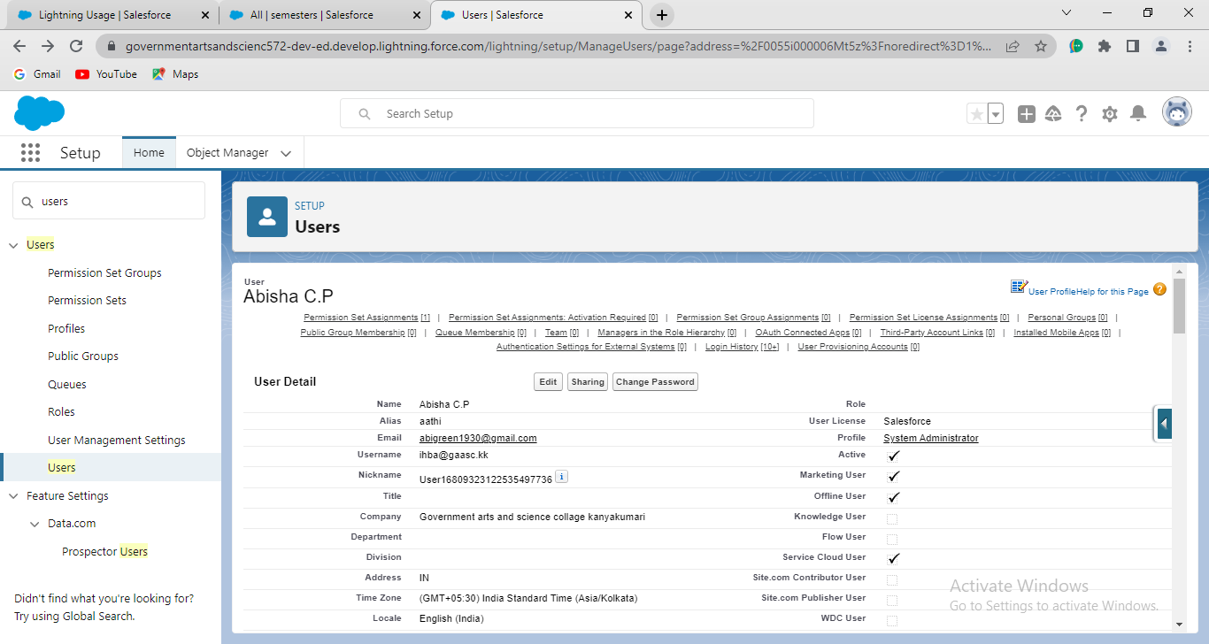

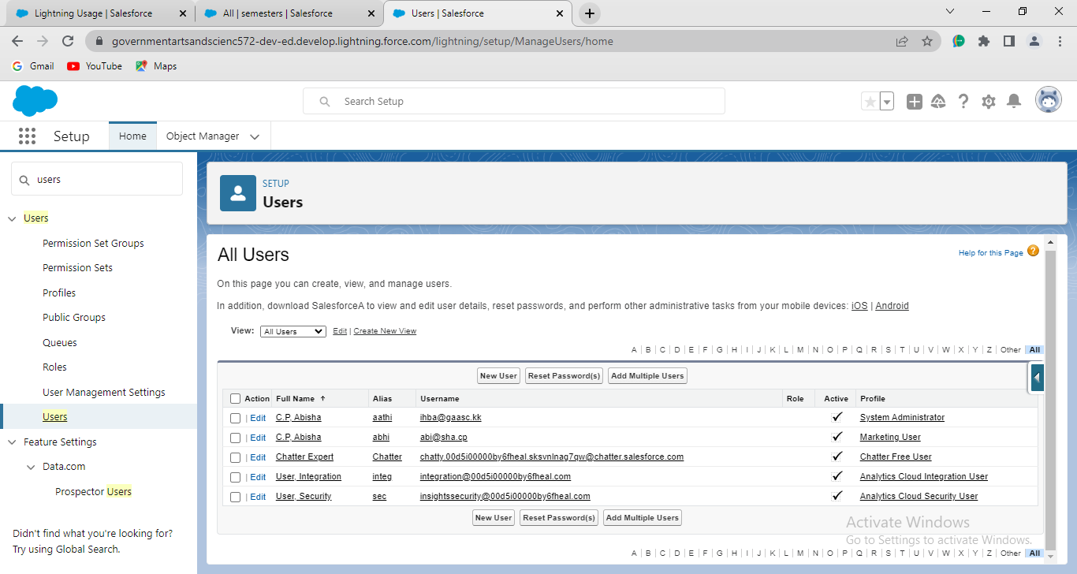

**Activity-5(Reports)**

Creation of reports:

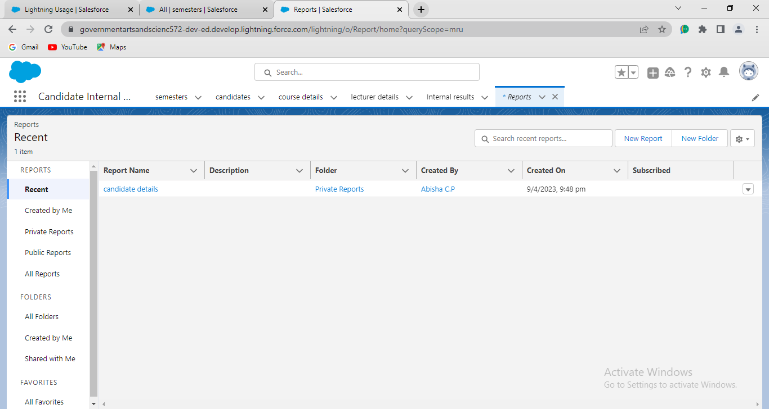

**Activity-6(Dashboard)**

Creation of a Dashboard:

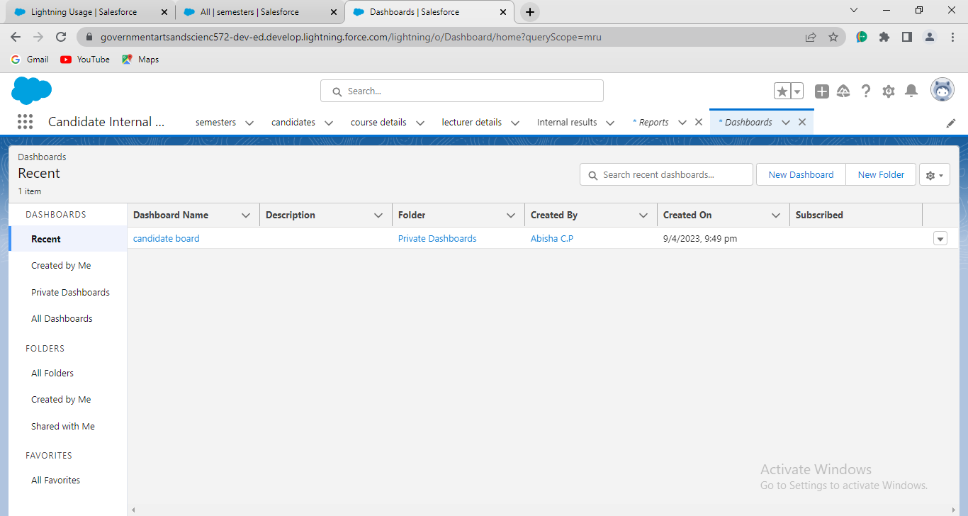

1. **Trailhead Profile Public URL**

**Team lead-** <https://trailblazer.me/id/abicp1>

**Team Member 1-** <https://trailblazer.me/id/abisl3>

**Team Member 2-** <https://trailblazer.me/id/abiss34>

**Team Member 3-** <https://trailblazer.me/id/abitj1>

**Team Member 4-** <https://trailblazer.me/id/abiss35>

1. **ADVANTAGES & DISADVANTAGES**

Advantages:

* It helps us to create objects, fields and relationship, lightning app, users, reports, dashboards.
* By doing this project we gain more knowledge about sales force.
* We learned about app creation in lightning app milestone.
* We gain some computer knowledge by doing this project.
* It is very helpful to our studies and career

Disadvantage

* There is no disadvantage in this project.
* Network problem is the only problem for doing this process.

1. **APPLICATION**

* The solutions of this project can be applied in our future job.

1. **CONCLUSION**

Implementing CRM for Result Tracking of a Candidate with Internal marks. Sales force is game changing technology, with a host of productivity-boosting features that helps us to sell smarter and faster. More knowledge is gained by this project. We create apps also, finally this project is very use full for the students.

1. **FUTURE SCOPE**

This project was initiated for us to know about sales force and to get good career. The key objectives of this project is to create, objects, fields and relationship, report, dashboard . Main goals of this project is to deliver the importance about sales force.